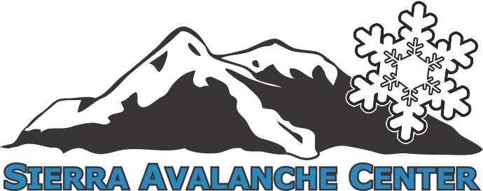
Scholarship Application
Please download a copy of this application and fill it out. Once you are done email it to scholarships@sierraavalanchecenter.org
* Required fields
* Name (first and last):
* Date of Birth:
* Email:
* Phone:
* Mailing Address (include city, state, and zip code):
* Gender: Female ⬜ Male ⬜
* What course would you like a scholarship for?
*What avalanche courses have you taken previously, if any?
* Do you currently work as an avalanche professional? (check box for patroller, guide, pro snowmobiler, other, describe if other)

* For which organization, if professional?
* Essay Submission: (500 words or less)
The scholarship will be awarded based upon the applicant’s written response.
Please describe how this scholarship will help you personally and/or professionally? What do you hope to gain from this course, and how to you plan to use what you hope to gain?

